Meraki As Built

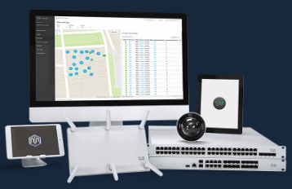

|  |  |  |
| --- | --- | --- |
| Prepared By | Prepared For | Date |
|  |  |  |